Sales Report Pipeline — Function-Level Flow Diagram
Written 31 July 2026. It describes the system as it was on that day.
This is the technical companion to the Team Guide and to the non-technical flow diagram. It is the same pipeline, drawn at the level of functions, tasks and exceptions. Every line reference was read from the repository at /opt/prefect/prod/code/sales_report_extraction on 31 July 2026 and is cited as file.py:line.
The nine stage names used in the non-technical document are carried through here so the two can be read side by side. They map onto the code as follows — note that process_email is called from the flow body, not from fetch_and_route_emails.
Stage | Function or call site | File and line
Read the rules | SharePointRuleLoader.load_rules | config_loader.py:135-294
Find the email | GraphClient.search_emails | main.py:56` / `graph_client.py:38-76
Check the email | per-email guard chain | main.py:60-92
Get the file | download_from_html_link` / `download_attachment | main.py:131-143
File the original | `SharePointUploader.upload_file` ("Raw") | main.py:145
Parse or pass through | ProcessingEngine.process_file | main.py:146` / `file_processor.py:37-98
Check the figures | validation gate, `apply_event_lookups` | file_processor.py:70-71`, `:76-78
Deliver | upload_file` ("Processed"), `upload_to_sftp | main.py:156`, `main.py:159
Stamp | GraphClient.tag_email`, `update_last_run | main.py:175`, `main.py:178

1. The rule-loading path
Nothing about email happens until the rules have been read. fetch_and_route_emails opens with all_rules = rule_loader.load_rules() (main.py:43), and that call reaches live SharePoint every run. There is no JSON fallback, no on-disk cache and no try around the Graph calls — the rules file config/show_reporting_rules.json now carries only global_settings (paths), so a Graph outage means no rules at all.
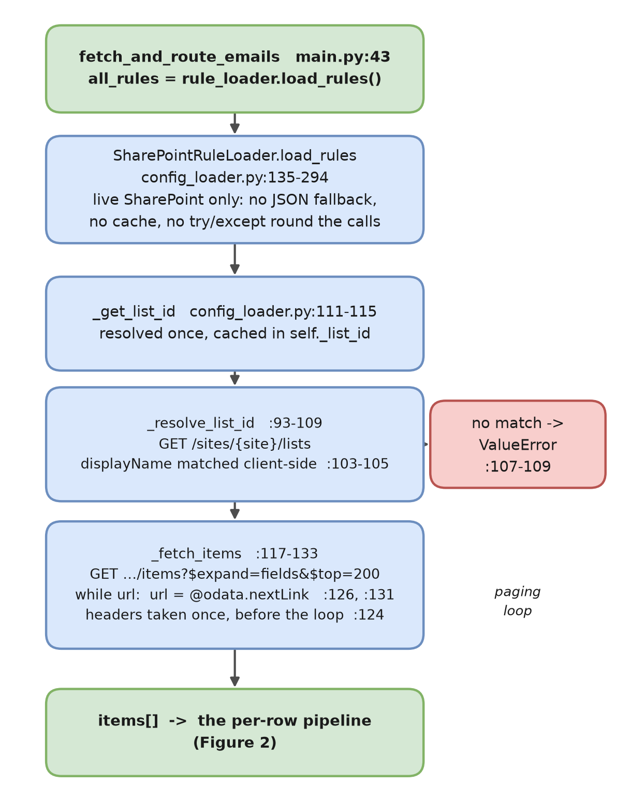
Figure 1 — Read the rules: how load_rules reaches the SharePoint list.
The list GUID is resolved by display name, client-side, because Graph will not filter lists on displayName reliably (config_loader.py:93-105); a miss raises ValueError(f"SharePoint list '{…}' not found on the configured site.") at :107-109. The GUID is then cached in self._list_id for the life of the process (:111-115). Paging in _fetch_items is a plain while url: loop following @odata.nextLink, and the authorisation header is built once, before the loop (:124) — a token expiring mid-paging would not be refreshed.
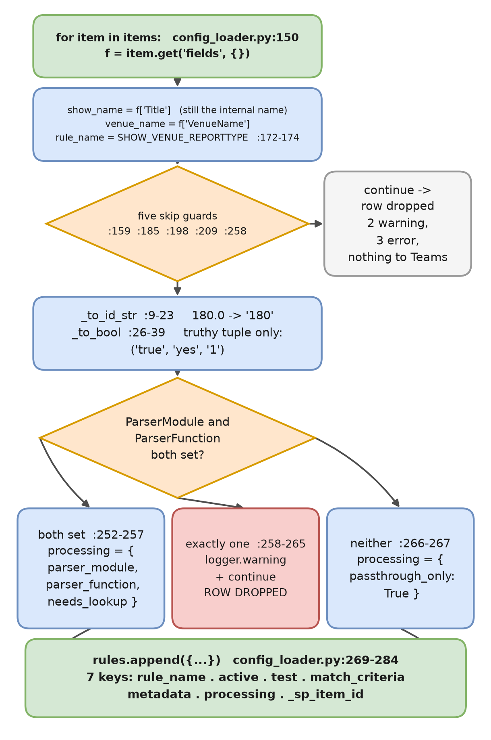
Figure 2 — Read the rules: the per-row pipeline, from raw list item to rule dict.

The five per-row skip guards
# | Condition | Line | Level | Gated on active?
1 | `Title` or `VenueName` blank | :159-164 | warning | no
2 | duplicate `rule_name` among active rows | :185-191 | error | yes
3 | `SubjectKeyword` blank | :198-203 | error | yes
4 | `SenderDomain` blank | :209-214 | error | yes
5 | exactly one of `ParserModule` / `ParserFunction` | :258-265 | warning | no

Each guard ends in continue, so a bad row is dropped and the rest of the load proceeds. None of them reaches Teams: the only trace is a single logger.warning or logger.error line, and the show simply stops arriving. Guards 2–4 are deliberately gated on active so a parked row cannot claim a name a live row needs (:176-178). The name itself is derived, not stored: "_".join(p for p in (show, venue, report_type) if p).upper().replace(" ", "_") at :172-174 — live examples include MAMMA_MIA!_ZURICH_ADVANCE.

Coercion: why bool(value) is avoided
def _to_bool(value) -> bool: # config_loader.py:26-39
if isinstance(value, bool):
return value
if value is None:
return False
return str(value).strip().lower() in ("true", "yes", "1")
The truthy set is the exact tuple ("true", "yes", "1"). The docstring at :27-34 states the reason plainly: bool("false") is True in Python, so bool(value) would silently flip an inactive rule to active. Anything outside the tuple — including "no", "0" and any typo — is False. _to_bool governs Active, Test and NeedsLookup.
_to_id_str (:9-23) exists because ShowID and DocumentID were created as Number columns, so Graph returns them as floats: an integral float becomes str(int(v)), turning 180.0 into "180". A non-integral value is not an error — 180.5 passes straight through as "180.5" and lands in the filename. That is the failure mode the Team Guide warns about in §5.

The three-way passthrough-versus-parser branch
if parser_module and parser_function: # config_loader.py:252-267
processing = {"parser_module": …, "parser_function": …,
"needs_lookup": _to_bool(f.get("NeedsLookup"))}
elif parser_module or parser_function:
logger.warning(f"Skipping rule '{rule_name}': ParserModule/ParserFunction "
f"must both be set, or both left blank.")
continue # <- the row is DROPPED
else:
processing = {"passthrough_only": True}
A half-filled parser pair is the only branch that discards a row rather than choosing a mode, and it is a warning, not an error. On the live list today that count is zero: 7 rows carry both parser columns, 15 carry neither.

The shape of a rule
{ # config_loader.py:269-284
"rule_name": "CHICAGO_TOUR_2027_LUGANO_ADVANCE",
"active": True, # _to_bool(f['Active'])
"test": True, # _to_bool(f['Test'])
"match_criteria": {"sender_domain", "subject_keyword", "attachment_type",
"attachment_source"?, "filename_keyword"?},
"metadata": {"show_name", "venue_name", "report_type", "show_id",
"venue_id", "document_id", "timezone",
"sales_day_offset_hours"},
"processing": {…}, # one of the three shapes above
"_sp_item_id": "23" # internal, used to stamp LastRun
}
Seven top-level keys. Two match_criteria keys are conditional: attachment_source is added only when the cell is non-blank (:223-225), and so is filename_keyword (:231-233) — which is why consumers must use .get() for both, as main.py:129 and main.py:136 do. metadata is always fully populated; timezone falls back to "UTC" silently, with no log line (:244). show_name comes from the column whose internal name is still Title (:155).
One malformed cell aborts the entire load
sales_day_offset_hours is built as int(f.get("SalesDayOffsetHours") or 0) at config_loader.py:245, outside every try block and inside the per-row loop. Any non-numeric text in that one cell — on any of the 22 rows, active or not — raises ValueError, load_rules never returns, fetch_and_route_emails fails, and no rules load at all. Every one of the five skip guards is a per-row 'continue'; this is not.

The reverse direction is update_last_run(item_id, when=None) (:296-320), a PATCH of {"LastRun": when.isoformat()} in Europe/London time onto .../items/{item_id}/fields. It ends in raise_for_status() at :319, so it does raise; what makes it non-fatal is the call site's own guard at main.py:177-180. LastRun is written but never read anywhere in the codebase.

2. The main call chain
Three tasks and one flow, all in main.py. There is no task_runner, no timeout_seconds and no cache_key_fn anywhere, and the entrypoint is sales_extractor_flow.serve(...) with cron="*/15 * * * *" at main.py:307-313 — .serve(), not .deploy(), so a scheduled run uses signature defaults only.
Decorator | Function | Line | retries
@flow(name="Sales Extractor Flow", log_prints=True) | sales_extractor_flow | 247-248 | none
@task(name="Fetch and Route Emails", retries=2) | fetch_and_route_emails | 39-40 | 2
@task(name="Process Email Attachment") | process_email | 98-99 | none
@task(name="Reset Failed Emails") | reset_failed_emails | 230-231 | none

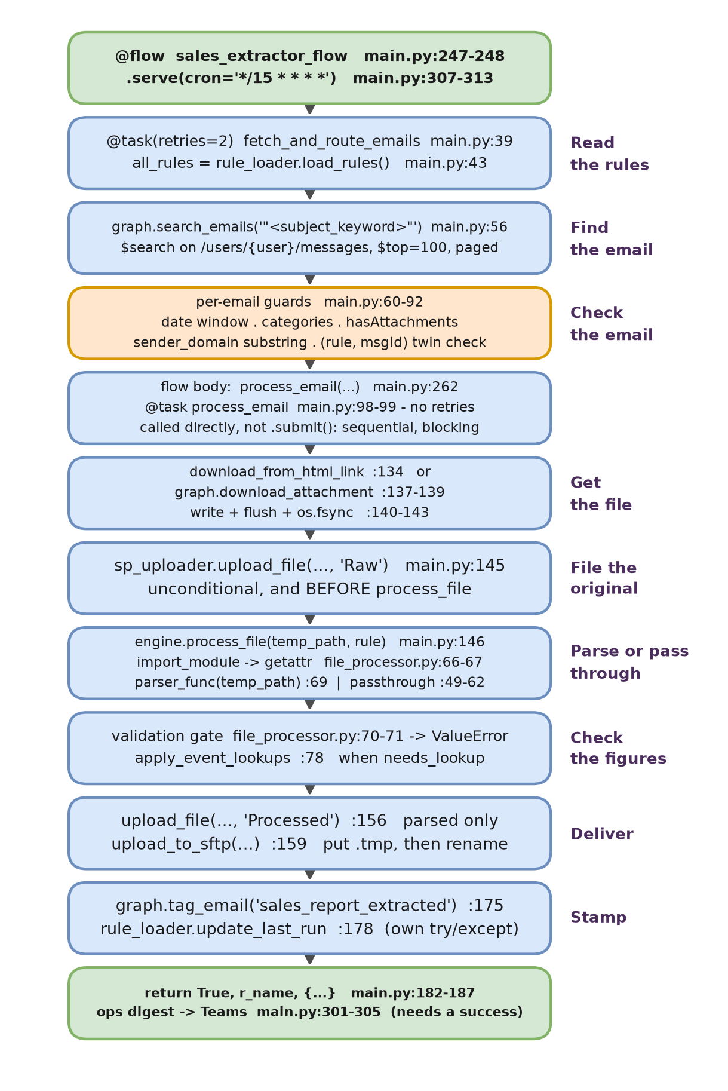
Figure 3 — The main call chain, function by function. Purple labels are the stage names shared with the non-technical document.

Walkthrough
Matching is rule-first. For each active rule the code asks Graph for emails (main.py:49-56); there is no “find the rule for this email” step, so an unmatched email is never seen. The query is f'"{crit["subject_keyword"]}"' passed as $search against /users/{target_user}/messages — the whole mailbox, not the Inbox folder — with $select naming eight fields including body (graph_client.py:41-48). $search is full-text, and the keyword is never re-checked against email['subject'], so a body-only match can queue. A 429 becomes an unbounded sleep-and-retry loop (graph_client.py:56-60).
The per-email guards run in order at main.py:60-92: received before the days_back window, or already carrying sales_report_extracted / _failed / _duplicate (:67); no attachment on a non-link rule (:72-74); crit['sender_domain'].lower() not in actual_sender — a substring test, not a domain test (:77). Duplicate handling is two independent mechanisms: Outlook categories, which are the real cross-run state store, and a within-run seen_fingerprints set keyed on the tuple (rule_name, internetMessageId) (:80, :89) — keyed that way on purpose, so two rules can each claim the same email. The sender mismatch branch is a bare else: skipped += 1 (:91-92) with no log line at all, which is the one blind spot in the fetch task.
process_email is called from the flow body, at main.py:262, inside for queued_sales_report in queued_sales_reports: — not from the fetch task. All three tasks are invoked directly; there is no .submit() anywhere, so execution is strictly sequential and blocking, and a live sweep of 22 rules takes roughly 2m50s because each rule issues its own Graph search.
Inside process_email (main.py:99-228), the sales-day offset is applied first (:120-123), then the standard name and the inbox path (:126-127). engine.generate_filename is a one-line wrapper (file_processor.py:33-35) over naming.generate_standard_filename — there is no function called generate_filename in naming.py. The file then arrives by one of two routes: download_from_html_link(html_body, temp_path) (:131-134) or graph.download_attachment(msg_id, expected_ext, filename_keyword) followed by write + flush() + os.fsync() (:135-143).
Two orderings matter. The Raw SharePoint upload is at :145 and engine.process_file at :146 — the untouched original is filed before anything touches it, so nothing is ever lost. And tagging is the last step, at :175, after SFTP. "Raw" and "Processed" are hardcoded literals at the two call sites, not rule fields; the destination is {show}/{venue}/{Raw|Processed} on the site's default /drive via a simple PUT …:/content (sharepoint_uploader.py:43-61) — no upload session, no size threshold, no explicit conflict behaviour and no folder-creation call.
process_file returns a 3-tuple (df, validation_result, output_path). For passthrough, df is None and the file is moved straight to the archive (file_processor.py:49-62). For a parser rule the module is imported dynamically and the function fetched by name (:66-67), the parser is called with one positional argument (:69), the single engine-level gate fires on FAILED or empty data (:70-71), apply_event_lookups runs only when needs_lookup (:76-78), and the processed file is written before the raw file is archived (:85-96). main.py never uses df. Note that UNVALIDATED passes the gate and is delivered, setting only needs_review (main.py:186).
Delivery and stamping. The Processed upload is skipped for passthrough rules (main.py:155-156) but upload_to_sftp runs for both (:159). SFTP is paramiko Transport plus SFTPClient.from_transport, password auth only (sftp_client.py:28-30), writing /{filename}.tmp then sftp.rename onto /{filename} (:33-48) so the downstream consumer never sees a partial file and the ingestion trigger fires exactly once. Only the credential pair changes in test mode (:12-18) — same host, same port, same flat server root; separation is by account plus the TEST. filename prefix, not by folder.

3. Retries, exceptions and the two Teams channels
There are exactly six try/except blocks in main.py. Four of them are silent.
# | Line | Catches | Log line | Teams | Outcome
1 | :84 | Exception as e | ⚠️ Failed to tag duplicate: {e} | none | swallowed; next email
2 | :189 | Exception as e | ❌ Failed: {e} | **dev** | swallowed; `return False`; run continues
3 | :179 | Exception as e | ⚠️ Could not update LastRun for {r_name}: {e} | none | swallowed; email still counts as successful
4 | :204 | Exception as db_err | none — bare `pass` | none | a failed sqlite write is invisible
5 | :225 | Exception | none — bare `pass` | none | failure tag lost; the email re-fails every 15 min
6 | :243 | Exception | none — bare `pass` | none | untag silently skipped

The main handler and the keyword sniff
except Exception as e: # main.py:189
logger.error(f"❌ Failed: {e}") # :190
engine.handle_failure(temp_path if 'temp_path' in locals() else "")
if isinstance(e, ValueError): # :193
error_details = str(e)
is_mapping = any(keyword in error_details.lower() # :195
for keyword in ["lookup", "mapping", "code", "unmapped"])
Classification is therefore a two-step string test on an exception message. isinstance(e, ValueError) decides between the two Action Required cards and the generic System Error card; is_mapping then decides which of the two Action Required headings is used, and whether a row is written to the sqlite lookup_failures table (:197-205). The missing code is pulled out of the message by regex — re.search(r"\{([^}]+)\}", …) at :201 — which is why the braces in f"Lookup Merge Failed: Unmapped codes found {{{unmapped_str}}}" (mapping.py:33) are load-bearing. Note also that logger.error(f"❌ Failed: {e}") carries no rule name, show, venue or message id — the identifying detail exists only on the Teams card, never in the log line.

Which channel, and how the webhook is chosen
def send_teams_notification(message, logger, facts=None, button_title=None,
button_url=None, channel="dev"): # notifications.py:5
if channel == "ops": # :11
webhook_url = os.getenv("TEAMS_WEBHOOK_OPS") # :12
else: # :13
webhook_url = os.getenv("TEAMS_WEBHOOK_DEV") # :14
Selection is exact, case-sensitive string equality against "ops" with dev as the else branch and as the parameter default. "Ops", "OPS" or any typo routes silently to dev; there is no validation and no third channel. A missing webhook logs ⚠️ Webhook URL for channel '{channel}' not set in .env. Skipping notification. and returns (:16-18). Card colour is chosen from the message text, not from severity, and the Attention test runs first (:21-25) — so an ops digest that merely mentions a failure renders red. Delivery failure is logged and swallowed (:93-94).
Call site | Channel | Message heading
main.py:208-213 | **dev** | ⚠️ **Action Required: Data Mapping Failed**` or `❌ **Action Required: File Parsing Failed**
main.py:216-221 | **dev** | ❌ **System Error: Extraction Failed**
main.py:301-305 | **ops** | 📊 **Batch Extraction Complete ({n} Files)**

Those are the only three call sites in the codebase. The ops digest is gated at main.py:277 on if (success_list or review_list) and not disable_notifications — it requires at least one success, so a run in which every queued email fails posts nothing at all to ops; only the per-failure dev cards go out. A run that queued nothing sends nothing and logs no summary either (:272).
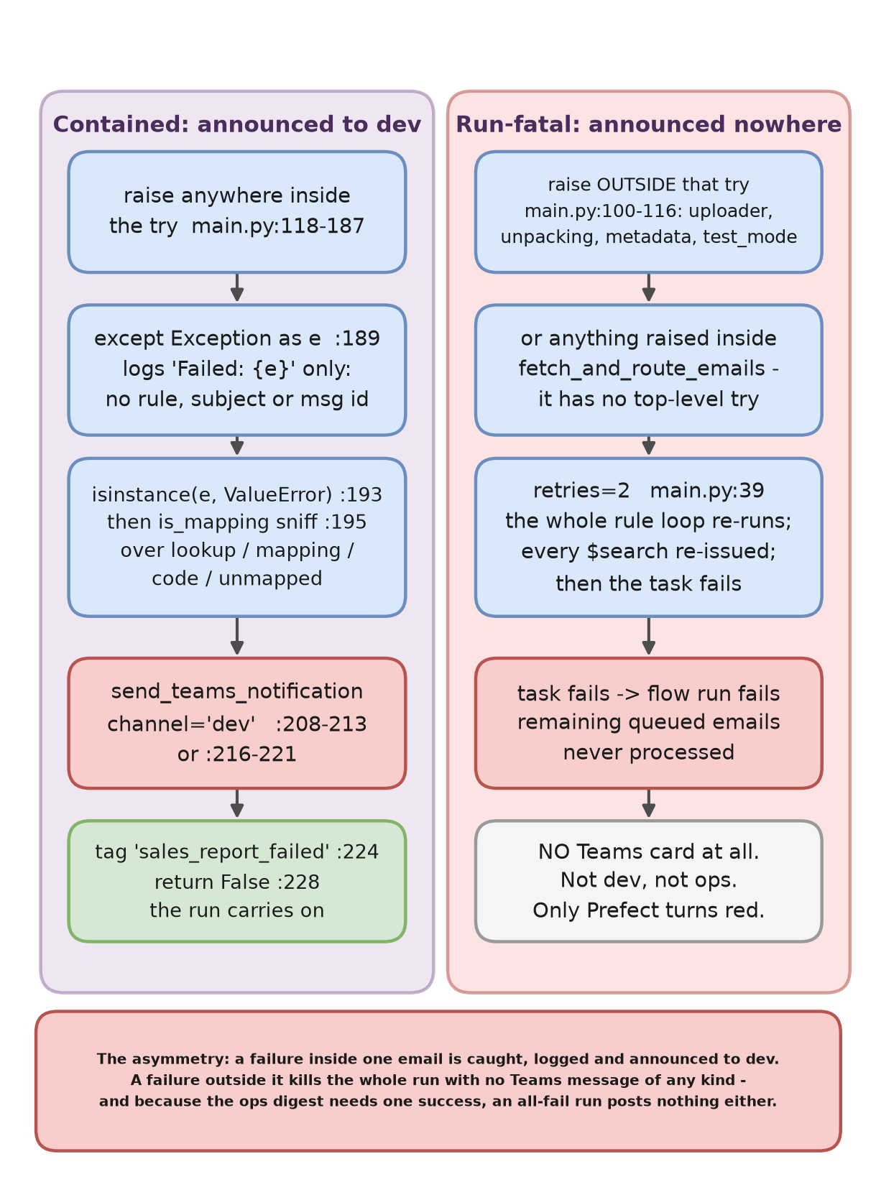
Figure 4 — The containment asymmetry: what is announced, and what is not.
The run-fatal paths post nothing to Teams
Everything from main.py:120 to :187 sits in one try, opened at :118. The code before it does not: SharePointUploader() at :100, the queued_sales_report / rule unpacking and rule['match_criteria']['attachment_type'].lower() at :103-107, the metadata reads at :109-110, test_mode at :114 and the opening log at :116. A KeyError there escapes process_email, and because process_email is called directly at :262 it kills the flow run — every remaining queued email included. fetch_and_route_emails has no top-level try either, so load_rules(), crit["subject_keyword"] and graph.search_emails can all fail the run; retries=2 re-runs the whole rule loop and re-issues every $search first. Neither path sends a Teams message of any kind. Per-email errors are contained and announced; run-level errors are silent, and only the Prefect dashboard shows them.

4. Verified defects and sharp edges
Each of these was read in the source, not inferred.
- A SharePoint failure is misreported as a data-mapping failure. sharepoint_uploader.py:70 raises ValueError(f"SharePoint upload failed with status {code}: {response.text}"). Graph error bodies are JSON containing "code":"…", and "code" is one of the four keywords in the is_mapping test at main.py:195. A permission or quota failure on the Raw upload therefore posts the ⚠️ Data Mapping Failed card and writes a bogus row into the sqlite lookup_failures table at :203 — pointing support at event-code mappings for a problem that is nothing to do with them.
- Tagging is last, so a tagging failure mislabels a delivered file. graph.tag_email(msg_id, "sales_report_extracted") is at main.py:175, after the SFTP delivery at :159. If it raises, the outer handler marks the email sales_report_failed although both SharePoint copies and the SFTP delivery already stand. Separately, graph_client.py:115 sends payload = {"categories": [tag_name]} — a full replace, not an append, so any pre-existing Outlook category on that message is destroyed. (untag_email at :136-155 does read-modify-write correctly; tag_email does not.)
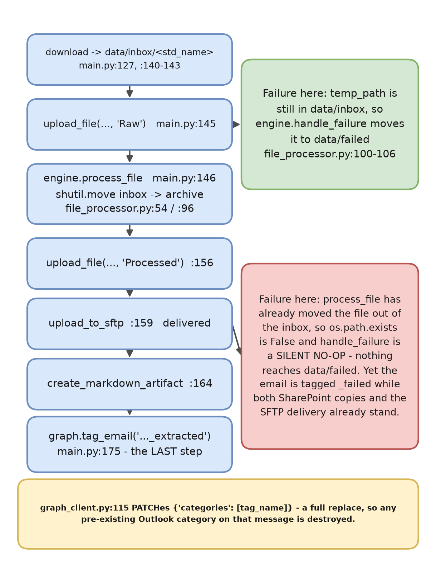
Figure 5 — The late-stage failure window: after process_file, handle_failure has nothing to move.
- handle_failure is a silent no-op for late-stage failures. engine.handle_failure is guarded by os.path.exists(temp_path) (file_processor.py:103). By the time process_file returns, the inbox file has already been moved to the archive (:54 or :96), so for any failure in the Processed upload, the SFTP delivery, the artifact or the tagging, the if is simply false and nothing lands in data/failed. There is no log line for the miss. A support person following the Team Guide to /opt/data/outlook_automation/data/failed after an SFTP failure will find nothing there.
- No SFTP host key verification. sftp_client.py:28-29 builds paramiko.Transport((host, port)) and calls transport.connect(username=…, password=…) with no hostkey= argument; there is no known_hosts load anywhere in the tree. The server's key is accepted unconditionally and never pinned. This is weaker than AutoAddPolicy, which is an SSHClient concept and would at least record the key on first use; Transport used this way records nothing.
- No timeout on any HTTP or SFTP call. Across graph_client.py, sharepoint_uploader.py, config_loader.py and link_extractor.py there is not one timeout= argument on any requests call, and none on the paramiko connect. A hung endpoint hangs the run until Prefect or the container is intervened with. Related: the nested cleanup at sftp_client.py:57-60 is a bare except: referencing sftp, which is unbound if the connect stage failed — so cleanup silently does nothing there, and a .tmp orphan can survive a mid-put failure.
- The dynamic import trusts the SharePoint cell verbatim. file_processor.py:66-67 is importlib.import_module(proc_config['parser_module']) then getattr(parser_module, proc_config['parser_function']). There is no f-string, no src.parsers. prefix added by code, no allow-list and no validation — the full dotted path is typed into the list by hand, and the function name with it. A typo raises ModuleNotFoundError or AttributeError, neither of which is a ValueError, so it is reported to dev as a generic ❌ System Error: Extraction Failed rather than as the configuration problem it is.
- link_extractor can only handle Sophos-wrapped URLs. The “Download Excel” branch at link_extractor.py:31 still feeds its href through extract_target_url_from_sophos at :38. A direct, unwrapped link has no u= query parameter, so the decoder returns None at :14 and :39-40 raises ValueError("Failed to decode the Sophos wrapper link.") — that message can therefore fire on a perfectly valid link. The decode itself ends in except Exception: return None at :22-23 with no log line at all, so the real cause is unrecoverable from the logs. There is also no content-type check, so a 200 HTML error page is written to disk as if it were the report (:54-55), failing later in the parser; and soup.find rather than find_all means the first matching link silently wins.
- The .xlsx output branch is dead code in production. file_processor.py:84 resolves getattr(parser_module, 'OUTPUT_EXT', '.csv') and :88-90 writes df.to_excel(...) when that is '.xlsx'. The only module declaring OUTPUT_EXT is the_bodyguard_bulgaria_parser.py:93, which no live rule references. The live Sofia outputs on disk confirm it: …Advance_233_267_347_26_07_2026.csv and …_29_07_2026.csv, with a single .xlsx dated 28/07 left over from when the spare was briefly wired. So _safe_sheet_name and the to_excel branch never execute today.
- Dead code and stale documentation. src/database.py builds a pyodbc SQL Server connection and nothing in the tree imports it. src/parsers/readme.md:16 introduces its list with “The following parsers are currently implemented and active” and then lists all eight, including the unused spare — seven are wired. And taiwan_jesus_christ_superstar_xlsx_parser.py:163-171 contains a soft-check loop that validates nothing: calc_qty = 0 is hardcoded and then discarded via _ = calc_qty, so the comparison the comment describes never happens.
- The sqlite table is write-only. error_db_client.py:23-35 creates one table, lookup_failures, written from exactly one place (main.py:203) and read or updated from nowhere; status is only ever 'Pending'. init_db chmods the directory 0o777 and the file 0o666 (:16, :42) as a Docker permission workaround. Nothing is ever cleaned out of data/processed or data/archive either — no retention step exists.

5. The parser layer
src/parsers/__init__.py is empty, 0 bytes. There is no registry: every parser is addressed only by the dotted string in its ParserModule cell and the name in ParserFunction. Seven are wired to live rules today; the eighth is a spare.
Show / Venue | Module | Entrypoint | Input | Library
Devil Wears Prada / Dominion | nederlandaer_devil_wears_prada_cumulative_extraction_pdf | same as module (`:27`) | .pdf | pdfplumber `extract_table`
JCS / Taiwan | taiwan_jesus_christ_superstar_xlsx_parser | same as module (`:204`) | .xlsx | openpyxl
JCS / Manila | ticketek_event_settlement_excel_parser | `extract_settlement_data` (`:28`) | .xls`/`.xlsx | pandas (xlrd/openpyxl)
JCS / Hong Kong | gmg_hk_jesus_christ_superstar_xlsx_parser | `extract_gmg_jcs_data` (`:29`) | .zip` → `.xlsx | zipfile + pandas
Silence of the Lambs / Malvern | malvern_theatre_contractual_report_pdf_parser | `extract_contractual_report` (`:27`) | .pdf | pdfplumber `extract_text(layout=True)`
The Bodyguard 2025 / Sofia | the_bodyguard_tour_bulgaria_sofia | same as module (`:581`) | `.xls` that is really HTML | BeautifulSoup `html.parser`
Chicago Tour 2027 / Lugano | chicago_tour_lugano_parser | same as module (`:395`) | .xlsx | openpyxl
— unused spare, no live rule — | the_bodyguard_bulgaria_parser | same as module (`:294`) | `.xls` that is really HTML | pandas `read_html`

All eight are call-compatible — one positional argument, returning (rows, ValidationResult) — and that return shape is the whole contract; ValidationResult is the three-field dataclass in src/models.py. Beyond that the layer has drifted:
- Eight entrypoint names, no convention. Four match the module name exactly, three are extract_* forms, and the spare matches its module too. No name is required, because getattr takes whatever string the SharePoint cell holds — which also means the wiring cannot be checked without reading the list.
- One parser names its parameter differently. malvern_theatre_contractual_report_pdf_parser.py:27 is def extract_contractual_report(pdf_path):; the other seven use file_path. Harmless while the engine calls positionally, as it does at file_processor.py:69, and an immediate break on any keyword call. Type hints are inconsistent too: three have none, two use a bare -> tuple, the rest are precise.
- The failure convention is split. chicago_tour_lugano_parser.py:464, taiwan_jesus_christ_superstar_xlsx_parser.py:261 and the_bodyguard_tour_bulgaria_sofia.py:648 each build a FAILED ValidationResult and then raise ValueError(f"Validation Failed: {validation_result.message}") themselves — the identical message the engine would have raised at file_processor.py:71 — so the return on the following line is unreachable on failure and the engine's gate never fires for those three. the_bodyguard_bulgaria_parser.py deliberately does not, and documents why. It is also the only one using get_universal_logger (:87, :299) rather than get_run_logger.
- nederlandaer_devil_wears_prada_cumulative_extraction_pdf is the most brittle. It reads pdf.pages[0] only (:35), finds its row by the exact string test row[0] == "Dominion Theatre" (:44), and then pulls every value by raw positional index — row[2], row[3], row[4], row[5], row[9], row[11] (:48-53) — with a hardcoded "Performance/Event Code": "CUMULATIVE" at :54. A column inserted anywhere left of index 11 silently shifts the figures. Its filename also misspells “Nederlander” as nederlandaer, and because the module path is typed by hand into SharePoint, the typo has to be reproduced exactly or the import fails.
- The well-engineered ones resolve columns by name. chicago_tour_lugano_parser and the_bodyguard_tour_bulgaria_sofia locate the header row and read through a name-to-index alias map (:121-139 and :231-241 respectively), so the table can move or its columns be reordered; the_bodyguard_bulgaria_parser:170-186 asserts an exact header tuple before trusting positional indices. The two Bodyguard parsers still disagree on how a blank field is represented — 0 at the_bodyguard_bulgaria_parser.py:225-226 versus "" at the_bodyguard_tour_bulgaria_sofia.py:407-408.
One further trap in this layer: apply_event_lookups merges on df['Performance/Event Code'] (mapping.py:18), and only two parsers emit that column — ticketek_event_settlement_excel_parser and nederlandaer…, the latter hardcoded to "CUMULATIVE". Ticking NeedsLookup on any of the other five would raise KeyError. No guard exists. Today exactly one live rule sets it — JCS / Manila — and its lookup file, data/lookups/287_220_event_dates.csv, is the only one present.

6. Test coverage
The suite runs green: 53 passed, 3 skipped. That figure was observed inside the running container — docker exec prefect-sales-extraction python -m pytest tests/ -q — and it cannot be reproduced on the host, where the system python3 has no pytest and there is no virtualenv. The three skips are live-integration tests gated on environment variables.
Genuinely well covered: tests/test_config_loader.py (18 test functions — both coercion helpers, all five skip guards, active-gating, pagination and the Test column), tests/test_sftp_client.py (the test-versus-live credential switch and the .tmp-then-rename sequence), and tests/test_file_processor.py — whose five tests are, however, all on the naming path.
Not covered at all:
- All eight parsers. Zero tests, no fixture files, no golden outputs. Every regex, hardcoded index, magic marker and totals reconciliation in the layer is unpinned — and this is precisely where vendor format drift bites.
- process_file is never really invoked. In tests/test_main.py it is a MagicMock (:86 sets mock_engine.process_file.side_effect), so the dynamic import, the getattr, the 3-tuple unpack and the write-then-archive ordering are all unverified by tests.
- apply_event_lookups — no direct test; only its error string is simulated. handle_failure, get_medallion_folders, _safe_sheet_name, OUTPUT_EXT resolution, the passthrough branch, both output-writing branches and the validation gate: none.
- src/link_extractor.py has no test file at all, and neither has update_last_run. On the Graph side, search_emails, download_attachment, tag_email and untag_email are untested, including the 429 loop, the pagination loop and the 409/412 retry.

Verification basis: every citation in this document was read from the working tree on 31 July 2026, alongside read-only Graph queries against the live rules list, the running container's logs, and the real output directories under /opt/data/outlook_automation/data.

